

Practical No.: 8
Aim –
To access and validate form fields using JavaScript events and design a Gym Admission Registration Form with live input validation.
Software/Tools Required –
- VSCode
- Chrome
- HTML5
- CSS3
- Javascript (ES6)
Experiment Program Code –
index.html
<!DOCTYPE html>
<html>
<head>
<title>Gym Admission Form</title>

<style>
* {
box-sizing: border-box;
}

:root {
--black: #121212;
--black-soft: #1b1b1b;
--orange: #ff7043;
--orange-dark: #e85d32;
--cream: #f8f6f2;
--white: #ffffff;
--text: #202020;
--muted: #858585;
--border: #e4e1dc;
--error: #d94b4b;
--success: #2f855a;
}

body {
margin: 0;
min-height: 100vh;
font-family: "Segoe UI", Arial, sans-serif;
background:
radial-gradient(
circle at 8% 15%,
rgba(255, 112, 67, 0.13),
transparent 25%
),
radial-gradient(
circle at 92% 85%,
rgba(255, 112, 67, 0.10),
transparent 25%
),
#eceae6;
display: flex;
align-items: center;
justify-content: center;
padding: 25px;
}

.container {
width: min(960px, 100%);
background: var(--white);
border-radius: 22px;
overflow: hidden;
display: grid;
grid-template-columns: 34% 66%;
box-shadow:
0 25px 70px rgba(0, 0, 0, 0.13),
0 5px 20px rgba(0, 0, 0, 0.05);
}

.side {
position: relative;
overflow: hidden;
padding: 38px 32px;
min-height: 570px;
background:
radial-gradient(
circle at 80% 30%,
rgba(255, 112, 67, 0.18),
transparent 30%
),
linear-gradient(155deg, #222222, #101010);
color: white;
display: flex;
flex-direction: column;
justify-content: space-between;
}

.side::before {
content: "";
position: absolute;
width: 330px;
height: 330px;
border: 1px solid rgba(255, 112, 67, 0.18);
border-radius: 50%;
top: 95px;
left: -180px;
}

.side::after {
content: "";
position: absolute;
width: 220px;
height: 220px;
border: 45px solid rgba(255, 255, 255, 0.025);
border-radius: 50%;
right: -150px;
bottom: -100px;
}

.logo {
position: relative;
z-index: 2;
font-size: 18px;
font-weight: 900;
letter-spacing: 3px;
}

.logo span {
color: var(--orange);
}

.side-content {
position: relative;
z-index: 2;
}

.side-icon {
width: 58px;
height: 58px;
border-radius: 16px;
background: rgba(255, 112, 67, 0.12);
border: 1px solid rgba(255, 112, 67, 0.3);
display: flex;
align-items: center;
justify-content: center;
font-size: 28px;
margin-bottom: 24px;
}

.side-content h1 {
font-size: 36px;
line-height: 1.05;
letter-spacing: -1.5px;
margin-bottom: 15px;
}

.side-content h1 span {
color: var(--orange);
}

.side-content p {
color: #9c9c9c;
font-size: 13px;
line-height: 1.7;
max-width: 240px;
}

.side-bottom {
position: relative;
z-index: 2;
}

.mini-info {
display: flex;
gap: 10px;
margin-bottom: 24px;
}

.mini-box {
flex: 1;
padding: 12px 9px;
border-radius: 9px;
background: rgba(255,255,255,0.045);
border: 1px solid rgba(255,255,255,0.07);
}

.mini-box strong {
display: block;
color: white;
font-size: 16px;
margin-bottom: 3px;
}

.mini-box span {
color: #777;
font-size: 8px;
text-transform: uppercase;
letter-spacing: 0.8px;
}

.credit {
color: #686868;
font-size: 9px;
line-height: 1.7;
}

.credit strong {
color: #a2a2a2;
font-weight: 600;
}

.form-area {
padding: 42px 48px;
background: var(--cream);
display: flex;
align-items: center;
}

.form-wrapper {
width: 100%;
}

.header {
display: flex;
align-items: flex-end;
justify-content: space-between;
margin-bottom: 27px;
}

.header-label {
color: var(--orange-dark);
font-size: 9px;
font-weight: 800;
letter-spacing: 2px;
text-transform: uppercase;
margin-bottom: 7px;
}

h2 {
margin: 0;
color: var(--text);
font-size: 30px;
font-weight: 800;
letter-spacing: -0.8px;
}

h2 span {
color: var(--orange);
}

.form-number {
width: 34px;
height: 34px;
border-radius: 50%;
background: #fff;
border: 1px solid var(--border);
color: #9a958d;
display: flex;
align-items: center;
justify-content: center;
font-size: 11px;
font-weight: 700;
}

.form-grid {
display: grid;
grid-template-columns: 1fr 1fr;
column-gap: 20px;
}

.field {
margin-bottom: 10px;
}

label {
display: block;
color: #48443f;
font-size: 10px;
font-weight: 800;
letter-spacing: 1px;
text-transform: uppercase;
margin-bottom: 6px;
}

input,
select {
width: 100%;
height: 45px;
padding: 0 13px;
border: 1px solid var(--border);
border-radius: 8px;
outline: none;
background: white;
color: var(--text);
font-size: 13px;
transition: 0.2s ease;
}

input::placeholder {
color: #aaa6a0;
}

input:focus,
select:focus {
border-color: var(--orange);
box-shadow: 0 0 0 3px rgba(255, 112, 67, 0.10);
}

input:hover,
select:hover {
border-color: #c7c2bb;
}

select {
cursor: pointer;
}

.error {
display: block;
min-height: 16px;
color: var(--error);
font-size: 10px;
margin-top: 3px;
}

.membership {
grid-column: span 2;
}

.membership select {
height: 47px;
}

button {
width: 100%;
height: 48px;
margin-top: 13px;
border: none;
border-radius: 8px;
background: var(--black);
color: white;
font-size: 11px;
font-weight: 800;
letter-spacing: 1.5px;
cursor: pointer;
transition: 0.25s ease;
}

button:hover {
background: var(--orange);
transform: translateY(-2px);
box-shadow: 0 10px 22px rgba(255, 112, 67, 0.20);
}

button:active {
transform: translateY(0);
}

.success {
min-height: 18px;
color: var(--success);
font-size: 12px;
font-weight: 700;
text-align: center;
margin: 13px 0 0;
}

@media (max-width: 800px) {
body {
padding: 15px;
}

.container {
grid-template-columns: 1fr;
}

.side {
min-height: 390px;
}

.form-area {
padding: 40px 30px;
}
}

@media (max-width: 550px) {
.side {
padding: 30px 25px;
}

.side-content h1 {
font-size: 30px;
}

.form-area {
padding: 35px 22px;
}

.form-grid {
grid-template-columns: 1fr;
}

.membership {
grid-column: span 1;
}

.header {
align-items: flex-start;
}
}
</style>
</head>

<body>

<div class="container">

<div class="side">

<div class="logo">
IRON<span>FIT</span>
</div>

<div class="side-content">

<div class="side-icon">
💪
</div>

<h1>
Gym<br>
<span>Admission</span>
</h1>

<p>
Register your details and choose a membership
plan to complete your gym admission.
</p>

</div>

<div class="side-bottom">

<div class="mini-info">

<div class="mini-box">
<strong>24/7</strong>
<span>Access</span>
</div>

<div class="mini-box">
<strong>50+</strong>
<span>Equipment</span>
</div>

<div class="mini-box">
<strong>10K+</strong>
<span>Members</span>
</div>

</div>

<div class="credit">
Designed by <strong>Sanskruti Gorle</strong><br>
PRN: <strong>24070521025</strong>
</div>

</div>

</div>

<div class="form-area">

<div class="form-wrapper">

<div class="header">

<div>
<div class="header-label">
Registration
</div>

<h2>
Member <span>Details</span>
</h2>
</div>

<div class="form-number">
01
</div>

</div>

<form id="gymForm">

<div class="form-grid">

<div class="field">
<label>Full Name</label>
<input
type="text"
id="name"
placeholder="Enter your full name"
>
<span id="nameError" class="error"></span>
</div>

<div class="field">
<label>Age</label>
<input
type="number"
id="age"
placeholder="Enter your age"
>
<span id="ageError" class="error"></span>
</div>

<div class="field">
<label>Email</label>
<input
type="email"
id="email"
placeholder="Enter your email"
>
<span id="emailError" class="error"></span>
</div>

<div class="field">
<label>Mobile Number</label>
<input
type="text"
id="mobile"
placeholder="Enter 10-digit number"
>
<span id="mobileError" class="error"></span>
</div>

<div class="field membership">

<label>Membership Plan</label>

<select id="plan">
<option value="">Select Plan</option>
<option>Monthly</option>
<option>Quarterly</option>
<option>Yearly</option>
</select>

<span id="planError" class="error"></span>

</div>

</div>

<button type="submit">
JOIN NOW&nbsp;&nbsp; →
</button>

<p id="result" class="success"></p>

</form>

</div>

</div>

</div>

<script>

// Name Validation (input event)
document.getElementById("name").addEventListener("input", function(){
let name=this.value;
if(/^[A-Za-z ]+$/.test(name)){
document.getElementById("nameError").innerHTML="";
}else{
document.getElementById("nameError").innerHTML="Only letters allowed.";
}
});

// Age Validation (blur event)
document.getElementById("age").addEventListener("blur", function(){
let age=this.value;
if(age>=16 && age<=60){
document.getElementById("ageError").innerHTML="";
}else{
document.getElementById("ageError").innerHTML="Age must be between 16 and 60.";
}
});

// Email Validation (input event)
document.getElementById("email").addEventListener("input", function(){
let email=this.value;
let pattern=/^[^\s@]+@[^\s@]+\.[^\s@]+$/;

if(pattern.test(email)){
document.getElementById("emailError").innerHTML="";
}else{
document.getElementById("emailError").innerHTML="Invalid email.";
}
});

// Mobile Validation (input event)
document.getElementById("mobile").addEventListener("input", function(){
let mobile=this.value;

if(/^\d{10}$/.test(mobile)){
document.getElementById("mobileError").innerHTML="";
}else{
document.getElementById("mobileError").innerHTML="Enter 10-digit mobile number.";
}
});

// Membership Validation (change event)
document.getElementById("plan").addEventListener("change", function(){
if(this.value==""){
document.getElementById("planError").innerHTML="Please select a plan.";
}else{
document.getElementById("planError").innerHTML="";
}
});

// Form Submission (submit event)
document.getElementById("gymForm").addEventListener("submit", function(e){

e.preventDefault();

if(
document.getElementById("nameError").innerHTML=="" &&
document.getElementById("ageError").innerHTML=="" &&
document.getElementById("emailError").innerHTML=="" &&
document.getElementById("mobileError").innerHTML=="" &&
document.getElementById("plan").value!=""
){
document.getElementById("result").innerHTML="Gym Admission Successful!";
}
else{
document.getElementById("result").innerHTML="";
alert("Please correct the errors before submitting.");
}
});

</script>

</body>
</html>

Output –

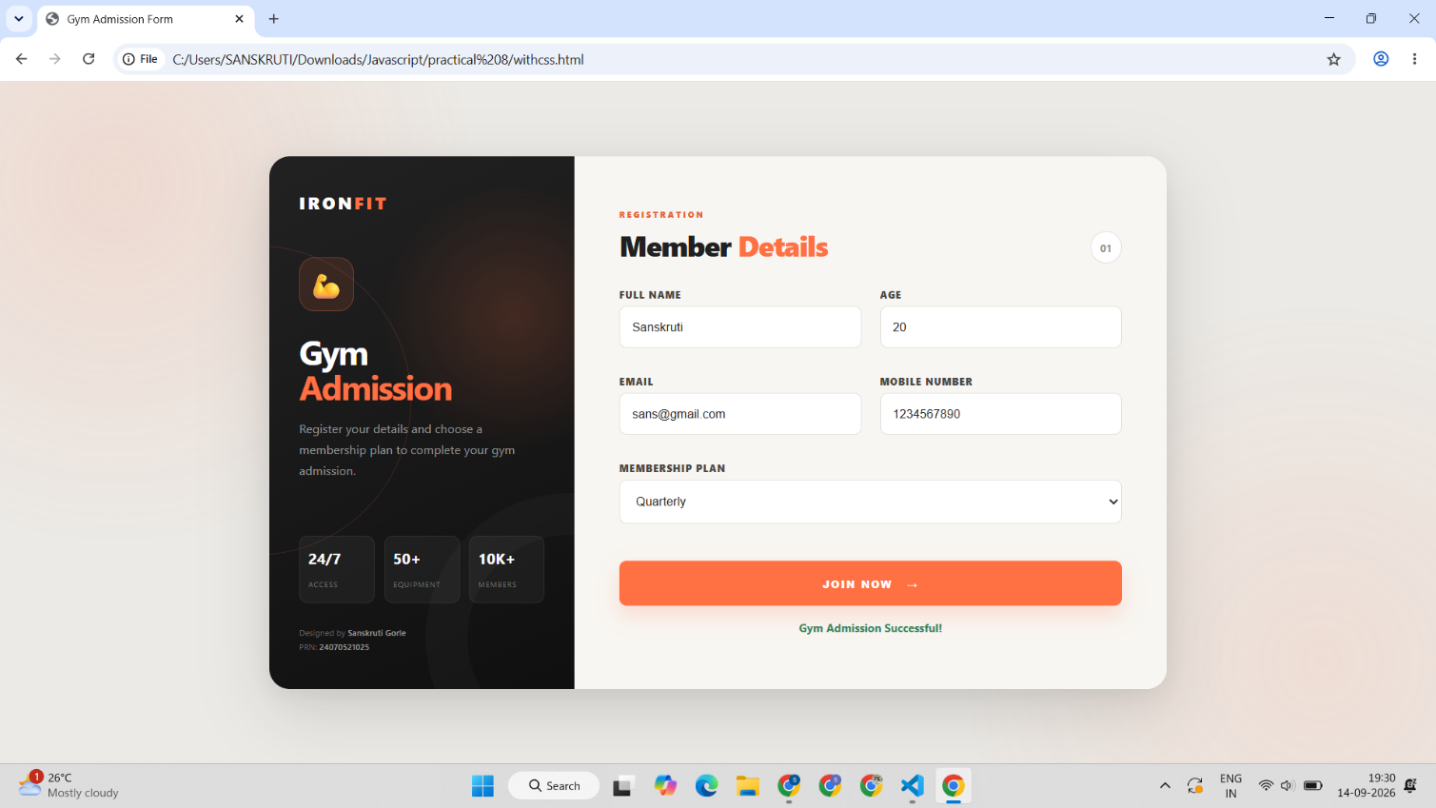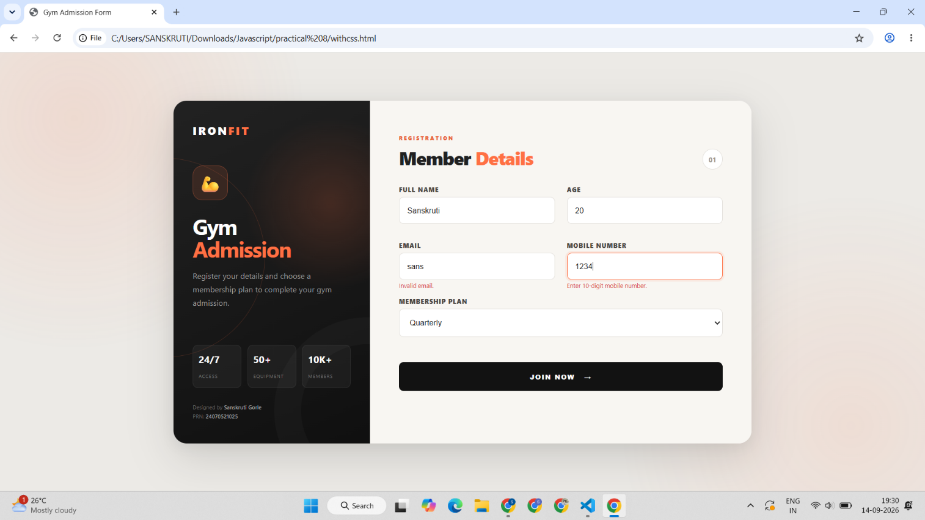

Case Study Title –
Gym Admission Registration Form Design a Gym Admission Registration Form using HTML, CSS and JavaScript. The form should collect basic information from a person who wants to register for gym admission. The form should contain:
Case Study Program Code –
index.html
<!DOCTYPE html>
<html>
<head>
<title>Gym Admission Form</title>

<style>
* {
box-sizing: border-box;
margin: 0;
padding: 0;
}

:root {
--red: #b51f2f;
--red-dark: #861522;
--red-light: #fff0f1;
--cream: #f7f2ed;
--white: #ffffff;
--black: #171416;
--text: #292427;
--muted: #8c8588;
--border: #ded8d5;
--error: #c52d3d;
}

html,
body {
width: 100%;
height: 100%;
}

body {
font-family: "Segoe UI", Arial, sans-serif;
background: #e5e1dd;
color: var(--text);
overflow: hidden;
}

.page {
width: 100%;
height: 100vh;
display: grid;
grid-template-columns: 42% 58%;
}

.left-panel {
position: relative;
min-height: 100vh;
padding: 46px 60px;
display: flex;
flex-direction: column;
justify-content: space-between;
overflow: hidden;
background:
radial-gradient(
circle at 8% 85%,
rgba(181, 31, 47, 0.28),
transparent 34%
),
linear-gradient(145deg, #2b2023, #100e0f);
color: white;
}

.left-panel::before {
content: "";
position: absolute;
width: 520px;
height: 520px;
border: 1px solid rgba(190, 78, 101, 0.16);
border-radius: 50%;
left: -290px;
bottom: -140px;
}

.left-panel::after {
content: "";
position: absolute;
width: 360px;
height: 360px;
border: 55px solid rgba(255, 255, 255, 0.025);
border-radius: 50%;
right: -240px;
top: -190px;
}

.brand {
position: relative;
z-index: 2;
font-size: 20px;
font-weight: 900;
letter-spacing: 4px;
}

.brand span {
color: #d9576b;
}

.hero {
position: relative;
z-index: 2;
}

.tag {
display: flex;
align-items: center;
gap: 10px;
color: #d9576b;
font-size: 9px;
font-weight: 800;
letter-spacing: 2px;
text-transform: uppercase;
margin-bottom: 20px;
}

.tag::before {
content: "";
width: 30px;
height: 2px;
background: var(--red);
}

.hero h1 {
font-size: clamp(45px, 5vw, 74px);
line-height: 0.88;
letter-spacing: -4px;
text-transform: uppercase;
margin-bottom: 23px;
}

.hero h1 span {
color: #c94357;
}

.hero p {
max-width: 390px;
color: #a99fa2;
font-size: 13px;
line-height: 1.75;
}

.stats {
position: relative;
z-index: 2;
display: flex;
gap: 38px;
}

.stat {
padding-left: 12px;
border-left: 2px solid var(--red);
}

.stat strong {
display: block;
font-size: 21px;
margin-bottom: 3px;
}

.stat span {
color: #777073;
font-size: 8px;
letter-spacing: 1.5px;
text-transform: uppercase;
}

.right-panel {
min-height: 100vh;
background: var(--cream);
padding: 35px 6vw;
display: flex;
align-items: center;
overflow: hidden;
}

.form-wrapper {
width: 100%;
max-width: 790px;
margin: auto;
}

.form-heading {
margin-bottom: 22px;
}

.form-heading small {
display: block;
color: var(--red);
font-size: 9px;
font-weight: 900;
letter-spacing: 2px;
text-transform: uppercase;
margin-bottom: 7px;
}

.form-heading h2 {
font-size: 34px;
line-height: 1;
letter-spacing: -1px;
}

.form-heading h2 span {
color: var(--red);
}

.section {
background: var(--white);
border: 1px solid var(--border);
border-radius: 13px;
padding: 15px 18px;
margin-bottom: 12px;
}

.section-title {
display: flex;
align-items: center;
gap: 9px;
margin-bottom: 11px;
}

.section-icon {
width: 28px;
height: 28px;
border-radius: 8px;
background: var(--red-light);
color: var(--red);
display: flex;
align-items: center;
justify-content: center;
font-size: 13px;
}

.section-title strong {
color: #514a4d;
font-size: 9px;
font-weight: 900;
letter-spacing: 1.5px;
text-transform: uppercase;
}

.section-title span {
margin-left: auto;
color: #aaa3a6;
font-size: 8px;
}

.field-label {
display: block;
color: #514a4d;
font-size: 9px;
font-weight: 900;
letter-spacing: 1px;
text-transform: uppercase;
margin-bottom: 6px;
}

input[type="text"],
select,
textarea {
width: 100%;
border: 1px solid var(--border);
border-radius: 8px;
outline: none;
background: #fdfcfa;
color: var(--text);
font-family: inherit;
font-size: 12px;
transition: 0.2s ease;
}

input[type="text"],
select {
height: 43px;
padding: 0 13px;
}

textarea {
height: 70px;
padding: 10px 13px;
resize: none;
line-height: 1.5;
}

input[type="text"]:focus,
select:focus,
textarea:focus {
background: white;
border-color: var(--red);
box-shadow: 0 0 0 3px rgba(181, 31, 47, 0.08);
}

.input-error {
border-color: var(--error) !important;
box-shadow: 0 0 0 3px rgba(197, 45, 61, 0.08) !important;
}

input::placeholder,
textarea::placeholder {
color: #b2abad;
}

.two-column {
display: grid;
grid-template-columns: 1fr 1fr;
gap: 14px;
}

.sex-options {
display: flex;
gap: 9px;
}

.sex-option {
position: relative;
flex: 1;
}

.sex-option input {
position: absolute;
opacity: 0;
}

.sex-option span {
height: 43px;
display: flex;
align-items: center;
justify-content: center;
border: 1px solid var(--border);
border-radius: 8px;
background: #fdfcfa;
color: #686165;
font-size: 11px;
cursor: pointer;
transition: 0.2s;
}

.sex-option span::before {
content: "";
width: 9px;
height: 9px;
border: 1px solid #aaa1a5;
border-radius: 50%;
margin-right: 7px;
}

.sex-option input:checked + span {
background: var(--red-light);
border-color: #bd8390;
color: var(--red);
font-weight: 700;
}

.sex-option input:checked + span::before {
background: var(--red);
border-color: var(--red);
box-shadow: inset 0 0 0 2px var(--red-light);
}

.sex-options.sex-error .sex-option span {
border-color: var(--error);
}

.checks {
display: flex;
gap: 10px;
}

.check-option {
position: relative;
flex: 1;
}

.check-option input {
position: absolute;
opacity: 0;
}

.check-option span {
height: 43px;
display: flex;
align-items: center;
justify-content: center;
padding: 8px;
border: 1px solid var(--border);
border-radius: 8px;
background: #fdfcfa;
color: #686165;
font-size: 10px;
cursor: pointer;
transition: 0.2s;
}

.check-option span::before {
content: "✓";
width: 17px;
height: 17px;
border: 1px solid #c6bec1;
border-radius: 4px;
margin-right: 7px;
display: flex;
align-items: center;
justify-content: center;
color: transparent;
font-size: 9px;
}

.check-option input:checked + span {
background: var(--red-light);
border-color: #bd8390;
color: var(--red);
font-weight: 700;
}

.check-option input:checked + span::before {
background: var(--red);
border-color: var(--red);
color: white;
}

.error {
display: block;
min-height: 13px;
padding-top: 3px;
color: var(--error);
font-size: 9px;
}

button {
width: 100%;
height: 46px;
border: none;
border-radius: 8px;
background: var(--red);
color: white;
font-size: 10px;
font-weight: 900;
letter-spacing: 1.7px;
cursor: pointer;
transition: 0.25s;
box-shadow: 0 8px 20px rgba(181, 31, 47, 0.16);
}

button:hover {
background: var(--red-dark);
transform: translateY(-2px);
}

button:active {
transform: translateY(0);
}

.credit {
display: flex;
justify-content: space-between;
padding-top: 10px;
margin-top: 12px;
border-top: 1px solid var(--border);
color: #9b9597;
font-size: 8px;
}

.credit strong {
color: #50494c;
}

@media (max-width: 900px) {
body {
overflow: auto;
}

.page {
height: auto;
min-height: 100vh;
grid-template-columns: 1fr;
}

.left-panel {
min-height: 390px;
padding: 35px 45px;
}

.right-panel {
min-height: auto;
padding: 40px 8vw;
overflow: visible;
}
}

@media (max-width: 600px) {
.left-panel {
padding: 30px 25px;
}

.hero h1 {
font-size: 48px;
}

.stats {
gap: 20px;
}

.right-panel {
padding: 30px 22px;
}

.two-column {
grid-template-columns: 1fr;
}

.checks {
flex-direction: column;
}

.credit {
flex-direction: column;
gap: 5px;
}
}
</style>
</head>

<body>

<div class="page">

<div class="left-panel">

<div class="brand">
FIT<span>FORM</span>
</div>

<div class="hero">

<div class="tag">
Gym Membership
</div>

<h1>
GYM<br>
<span>ADMISSION</span>
</h1>

<p>
Enter your personal information and fitness
details to complete your gym admission.
</p>

</div>

<div class="stats">

<div class="stat">
<strong>24/7</strong>
<span>Access</span>
</div>

<div class="stat">
<strong>50+</strong>
<span>Equipment</span>
</div>

<div class="stat">
<strong>10K+</strong>
<span>Members</span>
</div>

</div>

</div>

<div class="right-panel">

<div class="form-wrapper">

<div class="form-heading">

<small>
Registration Form
</small>

<h2>
Member <span>Information.</span>
</h2>

</div>

<form id="gymForm">

<div class="section">

<div class="section-title">

<div class="section-icon">
♙
</div>

<strong>
Personal Details
</strong>

<span>
01
</span>

</div>

<label class="field-label">
Name
</label>

<input
type="text"
id="name"
placeholder="Enter your full name"
>

<span
id="nameError"
class="error"
></span>

</div>

<div class="two-column">

<div class="section">

<div class="section-title">

<div class="section-icon">
○
</div>

<strong>
Sex
</strong>

<span>
02
</span>

</div>

<div class="sex-options" id="sexOptions">

<label class="sex-option">

<input
type="radio"
name="sex"
value="Male"
>

<span>
Male
</span>

</label>

<label class="sex-option">

<input
type="radio"
name="sex"
value="Female"
>

<span>
Female
</span>

</label>

</div>

<span
id="sexError"
class="error"
></span>

</div>

<div class="section">

<div class="section-title">

<div class="section-icon">
◉
</div>

<strong>
Eye Color
</strong>

<span>
03
</span>

</div>

<select id="eyeColor">

<option value="">
Select eye color
</option>

<option value="Green">
Green
</option>

<option value="Blue">
Blue
</option>

<option value="Brown">
Brown
</option>

<option value="Black">
Black
</option>

<option value="Hazel">
Hazel
</option>

</select>

<span
id="eyeError"
class="error"
></span>

</div>

</div>

<div class="section">

<div class="section-title">

<div class="section-icon">
✓
</div>

<strong>
Check All That Apply
</strong>

<span>
04
</span>

</div>

<div class="checks">

<label class="check-option">

<input
type="checkbox"
name="physical"
value="Over 6 feet tall"
>

<span>
Over 6 feet tall
</span>

</label>

<label class="check-option">

<input
type="checkbox"
name="physical"
value="Over 200 pounds"
>

<span>
Over 200 pounds
</span>

</label>

</div>

</div>

<div class="section">

<div class="section-title">

<div class="section-icon">
✎
</div>

<strong>
Athletic Ability
</strong>

<span>
05
</span>

</div>

<textarea
id="ability"
placeholder="Describe your athletic ability..."
></textarea>

<span
id="abilityError"
class="error"
></span>

</div>

<button type="submit">
ENTER MY INFORMATION&nbsp;&nbsp; →
</button>

</form>

<div class="credit">

<div>
Designed by
<strong>Sanskruti Gorle</strong>
</div>

<div>
PRN:
<strong>24070521025</strong>
</div>

</div>

</div>

</div>

</div>

<script>

document.getElementById("name").addEventListener("input", function() {

let name = this.value.trim();

if (name === "") {

document.getElementById("nameError").innerHTML =
"Name is required.";

this.classList.add("input-error");

} else if (!/^[A-Za-z ]+$/.test(name)) {

document.getElementById("nameError").innerHTML =
"Only letters and spaces are allowed.";

this.classList.add("input-error");

} else {

document.getElementById("nameError").innerHTML = "";

this.classList.remove("input-error");

}

});

document.querySelectorAll('input[name="sex"]').forEach(function(radio) {

radio.addEventListener("change", function() {

document.getElementById("sexError").innerHTML = "";

document.getElementById("sexOptions")
.classList.remove("sex-error");

});

});

document.getElementById("eyeColor").addEventListener("change", function() {

if (this.value === "") {

document.getElementById("eyeError").innerHTML =
"Please select your eye color.";

this.classList.add("input-error");

} else {

document.getElementById("eyeError").innerHTML = "";

this.classList.remove("input-error");

}

});

document.getElementById("ability").addEventListener("input", function() {

let ability = this.value.trim();

if (ability === "") {

document.getElementById("abilityError").innerHTML =
"Athletic ability is required.";

this.classList.add("input-error");

} else {

document.getElementById("abilityError").innerHTML = "";

this.classList.remove("input-error");

}

});

document.getElementById("gymForm").addEventListener("submit", function(e) {

e.preventDefault();

let name = document.getElementById("name");
let sex = document.querySelector('input[name="sex"]:checked');
let eyeColor = document.getElementById("eyeColor");
let ability = document.getElementById("ability");

let valid = true;

if (name.value.trim() === "") {

document.getElementById("nameError").innerHTML =
"Name is required.";

name.classList.add("input-error");

valid = false;

} else if (!/^[A-Za-z ]+$/.test(name.value.trim())) {

document.getElementById("nameError").innerHTML =
"Only letters and spaces are allowed.";

name.classList.add("input-error");

valid = false;

} else {

document.getElementById("nameError").innerHTML = "";

name.classList.remove("input-error");

}

if (!sex) {

document.getElementById("sexError").innerHTML =
"Please select your sex.";

document.getElementById("sexOptions")
.classList.add("sex-error");

valid = false;

} else {

document.getElementById("sexError").innerHTML = "";

document.getElementById("sexOptions")
.classList.remove("sex-error");

}

if (eyeColor.value === "") {

document.getElementById("eyeError").innerHTML =
"Please select your eye color.";

eyeColor.classList.add("input-error");

valid = false;

} else {

document.getElementById("eyeError").innerHTML = "";

eyeColor.classList.remove("input-error");

}

if (ability.value.trim() === "") {

document.getElementById("abilityError").innerHTML =
"Athletic ability is required.";

ability.classList.add("input-error");

valid = false;

} else {

document.getElementById("abilityError").innerHTML = "";

ability.classList.remove("input-error");

}

if (valid) {

alert("Gym Admission Successful!");

document.getElementById("gymForm").reset();

} else {

alert("Please correct the errors before submitting.");

}

});

</script>

</body>
</html>

Output –

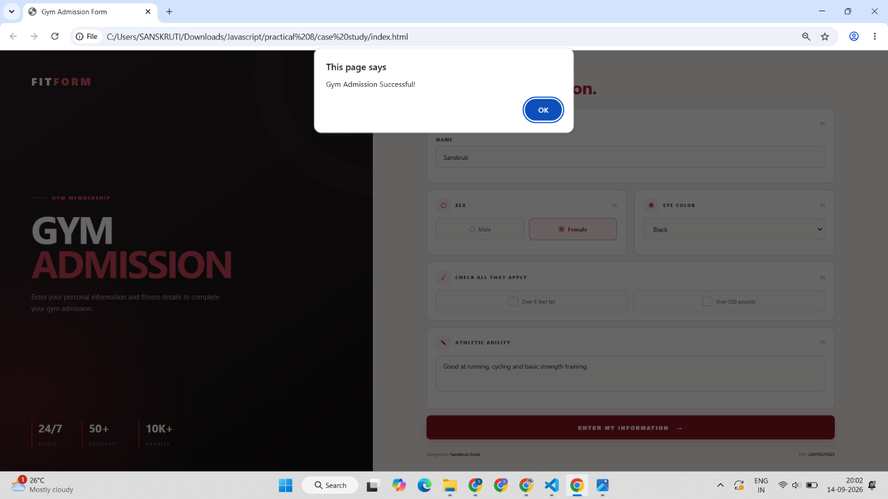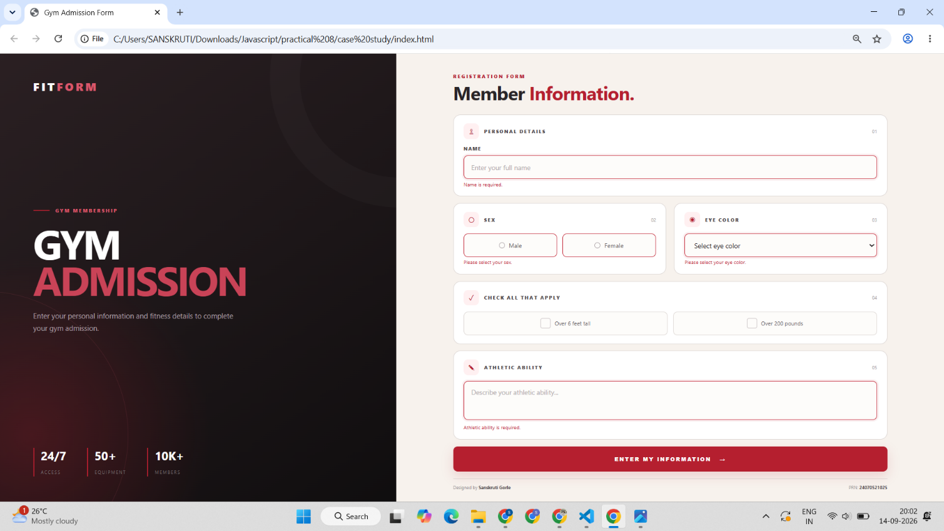

Conclusion –
In this experiment, a Gym Admission Registration Form was designed using HTML, CSS and JavaScript. Form fields were accessed and manipulated using the DOM. JavaScript events such as input, change, focus, blur and submit were used to perform live form validation. Invalid inputs were identified and appropriate messages were displayed to the user. The experiment demonstrated the practical use of JavaScript events and form validation for creating interactive web forms.

